Program Descriptions
Morning Meditation M,T, W, Th @ 7:15am
Start your morning with a clear mind through this group meditation session

Wellness Walk T, W @ 12:00pm
Enrich your physical, mental, and emotional wellness through a combination of physical exercise and fellowship. Join us as we take a lunch time walk around town and develop deeper connections with one another and the community

Making Recovery Easier T @ 1:30pm
This is an open meeting format, Open to all interested in making the path to recovery easier

Volunteer Orientation W @ 1:00pm
If you are interested in volunteering or completing community service at the Turning Point Center attend an orientation to learn more!

All Recovery Meeting W @ 1:30pm
Open facilitated group for anyone and everyone interested in recovery. All paths to recovery are welcome. Come share your journey with others!

Writing Workshop W @ 5:30pm
Pizza & Soda provided at 5:30, please sign up in advance to attend! Gary M is a writer in long-term recovery and will be facilitating this recovery based summer writing workshop! 6/18 – 8/20

Job Counseling W 1:00pm – 5:00pm
**NEW** Wednesdays from 1:00pm until 5:00pm we welcome Chuck Hafter, an experienced employment specialist, who will be offering job counseling, resume building, and interviewing training free of charge!

Recovery; Living the Full Life Th @ 11:00am
This group goes over the 8 components of wellness and how to live a full life in recovery

LifeRing Th @ 7:00pm
A non-traditional program that helps people stay sober by building personal recovery plans.

Liberation through Laughter F @ 5:30pm
Open group focused on increasing wellness through peer to peer support and loosening up through the joy of laughter

Celebrate Recovery Sat @ 1:00pm
A Christian based program that helps to overcome hurts, hang-ups, and habits. Explore the Recovery Process through the 8 steps and principles.

Sober Boxing Sun @ 11:00am
Come learn the basics and fundamentals of boxing! These skills can be utilized in many areas of a sober lifestyle.

Sunday at the Movies Sun @ 1:30pm
Come watch a great movie with us every Sunday at 1:30pm! Enjoy fun and fellowship with light refreshments and entertainment.

Recovery Video Showings

We are showing “The Anonymous People”, “The Hungry Heart”, and “Bill W”
Monday – Wednesday at 10:00am
FREE!! You are invited to join us!

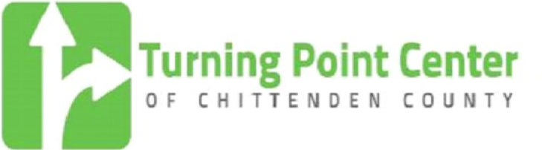

191 Bank Street (Second Floor)
Burlington, VT 05401

802.861.3150
www.turningpointcentervt.org

September 2014
CALENDAR

The Turning Point Center of Chittenden County is a dedicated, compassionate community that provides recovery support services in a safe, substance-free environment for individuals and families on multiple paths to self-discovery and sustained recovery.

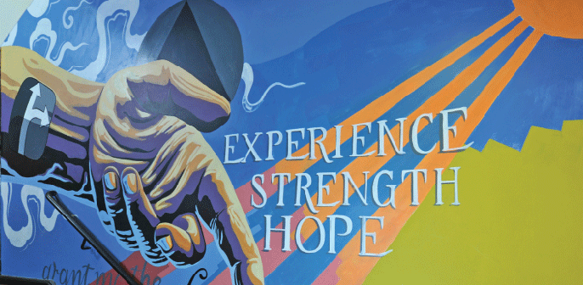

Recovery Support Hours
9am – 5pm Daily

Programming Hours
Sun : 9:00am – 7:30pm
Mon – Wed: 9:00am – 9:30pm
Thurs – Sat: 9:00am – 11:30pm

Sunday
9:00am Highlighters AA O/BB (BR)
11:00am Sober Boxing
1:30pm Sunday at the Movies (SR)
5:00pm Recovery Support Hours End
5:30pm Underearner’s Anonymous (SR)
6:00pm Into Action AA O/ST (BR)

Monday
7:15am Meditation (BR)
12:00pm The Clean Livers AA – O/L (BR)
2:00pm Before The Drink AA – O/D (BR)
5:00pm Recovery Support Hours End
6:30pm How It Works AA – O/D (BR)
8:00pm Step Into Recovery NA – O/ST (BR)

Tuesday
7:15am Meditation (BR)
11:30am L.I.T. – Closed (BR)
12:00pm Wellness Walk
1:30pm M.R.E. Making Recovery Easier
5:00pm Recovery Support Hours End
5:30pm Way of Life AA – O/BB/D (BR)
6:30pm Freed From Weed MA – O (SR)
7:00pm Proud & Sober AA – O/GLBT (BR)
8:30pm CA Meeting (BR)

Wednesday
7:15am Meditation (BR)
12:00pm Easy Does It NA O/H/RT (BR)
12:00pm Wellness Walk
1:00pm TPC Volunteer Orientation (SR)
1:00pm *NEW Job Counseling FREE (CR)
1:30pm All Recovery [AT ACT I]
2:00pm Mindfulness Techniques
5:00pm Recovery Support Hours End
5:30pm *NEW Writing Workshop
5:30pm Affected by Addiction (1st Wed)

Thursday
7:15am Meditation (BR)
11:00am Recovery: Living the Full Life
5:00pm Recovery Support Hours End
5:30pm CA Beginner’s Meeting (BR)
6:30pm Prayer and Meditation Meeting O/D (BR)
7:00pm LifeRing (SR)
8:00pm Freed From Weed II MA/O (BR)
10:00pm Candlelight AA – O/BB/D (BR)

Friday
5:00pm Recovery Support Hours End
6:30pm Faith Based Support Group
6:30pm Girls Night Out AA – O/W/D (BR)
8:00pm Freaky Friday AA – BB (BR)
10:00pm Candlelight AA – O (BR)

Saturday
12:00pm 12x4 AA – O/ST (BR)
1:00pm Celebrate Recovery
5:00pm Recovery Support Hours End
6:30pm Big Book Step AA – O/BB/ST (BR)
10:00pm Candlelight AA – O/BB/D (BR)

KEY
Big Room: (BR)
Small Room: (SR)
Common Room: (CR)



OPEN MIC NIGHT!
3rd Saturday of EVERY Month!
7:30pm
What does the Turning Point Offer?
The Turning Point Center of Chittenden County provides space for peer-to-peer recovery activities, fellowship, events, games, fitness, recovery related programs, 12 step meetings, & Recovery Coaching.

The Turning Point Center respects all paths to recovery. We understand that all areas of life need to be addressed. Other types of support provided to promote healthy living include resource referrals, social events such as open mic night, and athletic activities such as boxing, and yoga.

Our hope is to offer a variety of opportunities and supports to help create an encompassing path to recovery for each individual.

Our role is to provide support to those who choose to utilize recovery services and to assure that we provide a welcoming and safe environment.

*NEW Recovery Peer Support Workers
The Turning Point Center is proud to introduce Recovery Peer Support Workers! 5 days a week between 10am and 2pm our Recovery Peer Support Workers are available to assist guests in finding solutions to various hurdles that arise in our path to sustained recovery.

Recovery Coaching
A recovery coach is a mentor in recovery that helps you to build a healthy life.
Recovery Coaches work with you to
- Create a healthy vision for recovery, while supporting all paths to recovery
- Help make decisions about how to improve your life
- Create a Recovery Wellness Plan to help with the progress of your recovery
- Explore and connect with recovery resources
Recovery Coaches meet you where you are at in your journey to recovery. Whether you are drinking or using, already in recovery, or concerned about someone else’s addiction.

For more information or to get a coach, contact
Kim Morrill at 802.861.3150

