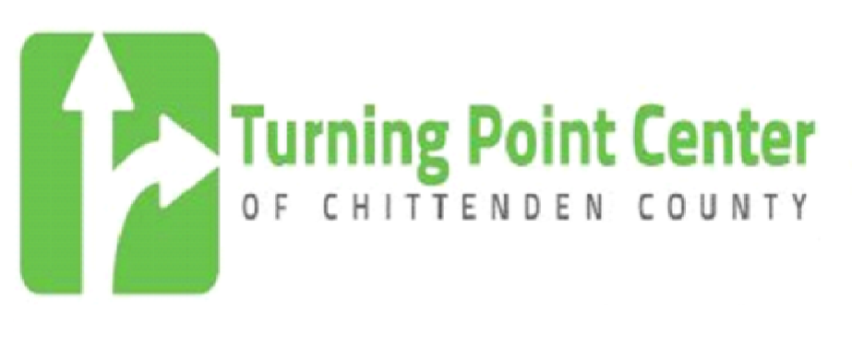

Contact: Gary De Carolis, Executive Director
802-861-3150
garyd@turningpointcentervt.org

PRESS RELEASE

On Wednesday, October 15, 2014, 5:00 PM to 6:00 PM, there will be a dedication and open house of the new Constance Robert Memorial Recovery Library at the Turning Point Center of Chittenden County, 191 Bank Street, Suite 200, Burlington, VT. The library has been made possible due to a generous gift from Paul Robert, son of the late Constance Robert. The public is welcome to attend the dedication. Barbara Cimaglio, Deputy Commissioner, Division of Alcohol and Drug Abuse Programs, Department of Health will offer remarks at the dedication.

The library will feature scores of books from various 12 step programs, alternative to twelve step material and fiction and non-fiction books all related to recovery from alcohol and drug addiction. Also the Center has been able to purchase a number of recovery oriented movies that will be used during the recovery support hours of the Center (9:00 AM to 5:00 PM) to enhance the Center’s program offerings. To complement the library a reading section has been created within the Turning Point Center so that guests of the Center can have a comfortable space to read and converse.

The Turning Point Center of Chittenden County is a dedicated, compassionate community that provides recovery support services in a safe, substance-free environment for individuals and families seeking self-discovery and sustained recovery.

191 Bank Street, Suite 200 - Burlington, VT 05401 - 802.861.3150 - www.turningpointcentervt.org

