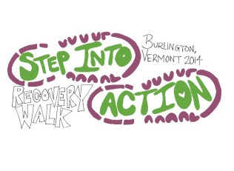
The Oxford Houses of the Greater Burlington Area present the 2nd annual:
Step into Action Recovery Walk
Registration form
Saturday, September 6 2014
Location: 2nd covered pavilion at Oakledge Park, Burlington, VT
Registration: 10am, Event: 11am-4pm
A day of fun, food and fellowship including:
*A healthy walk on the Burlington Bike Path (Distance of 3 miles)
*Amazing lunch time BBQ
*Fun Games in the park
*50/50 Raffle
*Auction
*Music provided by DJ/Live Band
*Friends and fellowship in the sunshine from 11am– 4pm
The purpose of the event is to recognize the important role that The Turning Point Center plays in the lives of so many people recovering from substance abuse issues in the Burlington, Vermont area.
This event will be run on donation from local businesses and your support! We are asking all participants to provide a $25.00 donation to attend this event. All proceeds raised from this event will benefit The Turning Point Center of Chittenden County, a non-profit organization whose mission is to help recovering people stay sober in a supportive environment. If any questions, please send an email to stepintoactionvt@gmail.com or call Kim @ 603-318-6907.
Please send completed registration form to the address listed below along with enclosed cash, check, or
money order(s) payable to Step Into Action:
Step Into Action
Women’s Oxford House
42 Bright Street
Burlington, VT 05401
Name: __________________________ Phone #: ________________ Email Address:_______________________
Street Address: _________________________ City/State:__________________________ Zip Code: __________
Gender (please circle): Female Male T-Shirt Size: S M L XL
Registration Fees: $25.00 _______ Additional Donation Amount: $___________ Total: $_____________
I am paying by: Cash_________ Check__________ Money Order__________
_____________________________________________________________________________________________
Race Waiver: I, the undersigned, understand the event I am entering carries the risk of personal injury or damage. I hereby waive and forfeit all rights I may have to file or make claims against The Oxford House of Burlington, The Turning Point of Chittenden County, any sponsoring organizations, and all persons connected with the walk for injuries I may suffer at this event on September 6th, 2014. I understand that refunds will not be made if the event is cancelled due to weather conditions or other circumstances beyond the control of the organizers. I also understand that strollers, wagons, and leashed dogs are only allowed on the cart paths, and that roller blades and bicycles are not allowed in the walk.
I will abide by these guidelines.
Participant Signature:_____________________________________________________ Date:_______________

